Submission:
• Email instructor or TA if there are any questions. You cannot look at others’ solutions or use others’ solutions, however, you can discuss it with each other. Plagiarism will be dealt with according to the course policy.
• Submission after due time will not be accepted.
Follow this naming convention for your report, it should highlight difficulties you faced and things you learn in this assignment. Naming Pattern ( Roll#_Assignment#.pdf e.g BSSE23000_Assignment2.pdf )
In this assignment you must perform the following steps:
Step 1: Sign in to your Github account. (https://github.com)
Step 2: Accept the assignment through the link posted in Google Classroom and after accepting clone the repository to your computer.
Step 3: Open draw.io from browser to draw flowcharts. ( https://app.diagrams.net/)
Step 4: Solve each question separately using draw.io tool.
Step 5: Save your flowcharts in .png format and paste them in word file, under the corresponding question.
Step 6: Paste all flowcharts in Git cloned folder.
Step 7: Commit the changes through Github App.
Step 8: Push the file to the repository.
Assignment Questions

Q1. Design a flowchart that calculates the area of a triangle given its base and height. Ensure the flowchart displays both the input values and the area.
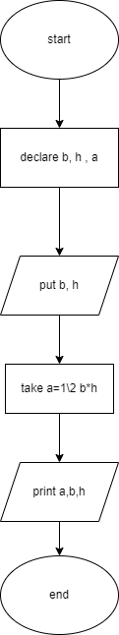

Q2. Design a flowchart using draw.io that outlines the steps involved in setting up and sending an email. Include symbols for decision-making and actions.
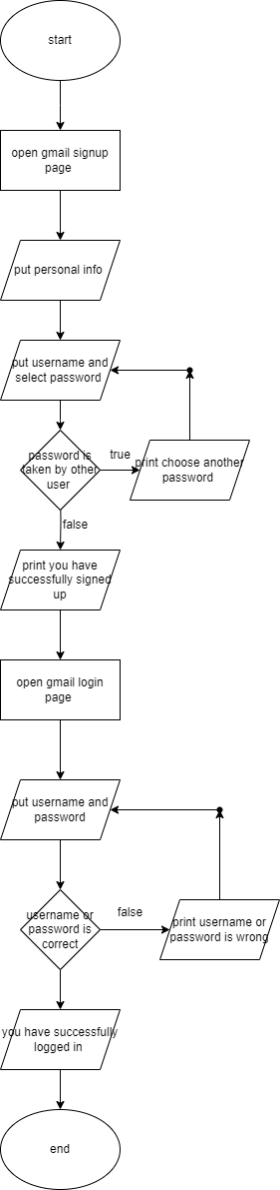

Q3. Design a flowchart using Draw.io that acts as a carrier counselor and suggest profession based on the user interests.
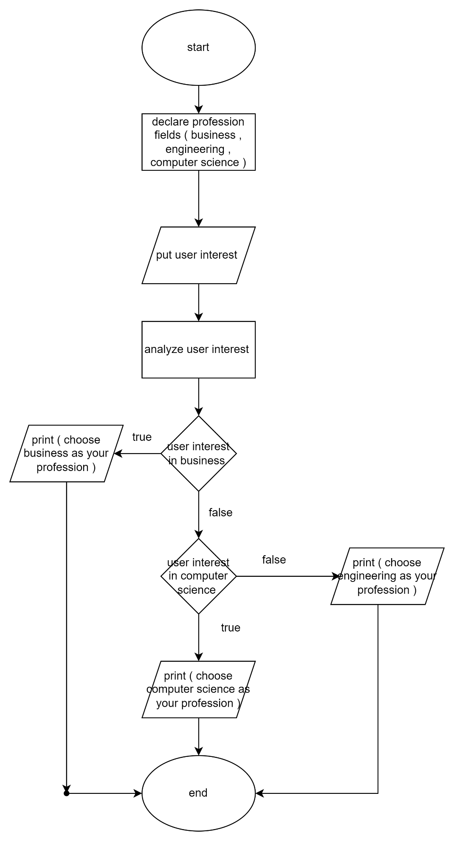

Q4. Illustrate a "Student Grading System" flowchart using Draw.io, including input of exam scores and the calculation of final grades. ( Greater than 90 A+, 80+ => A, 77+ => A-, 73+ => B+, 70+ => B , 67+ => B-, 63+ => C+, 60+=> C, 57+ =>C-, 53+ => D+, 50+ => D & less than 50 is F)
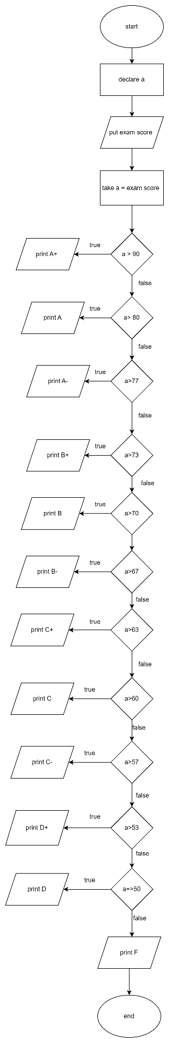

Q5. Draw a flowchart in Draw.io for the steps required to find the cost of x pens when the cost of each pen and quantity x are taken as input from the user.
